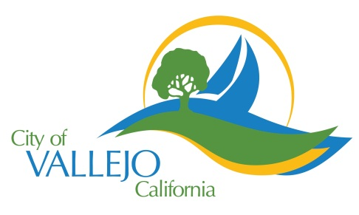
City of Vallejo
General Plan Working Group (GPWG)
Information

The City of Vallejo is seeking volunteers to be on the General Plan Working Group, a fifteen member committee who will advise staff during the preparation of the City’s new General Plan. A General Plan is often described as the “constitution” that guides the development of a city. It will establish a vision for Vallejo’s future, and the policies and implementation measures that will help it to achieve that vision. Among the issues it will address are land use, housing, open space, circulation, economic development, , public services, infrastructure, emergency preparedness and community health. It is the foundation on which all land use planning and regulatory decisions are made.

The General Plan Working Group (GPWG) will:
- Provide feedback and direction to the Economic and Community Development Department staff and the consultant team during the preparation of the General Plan update;
- Make recommendations to the Planning Commission and City Council at key project milestones;
- Host community workshops and other outreach events, and act as a sounding board for the community during the process; and,
- Communicate information about the General Plan Update to other Vallejo residents and encourage their friends, neighbors and colleagues to participate in the process.

It is anticipated that the GPWG will begin meeting in late September, 2013 and be dissolved upon completion of a first draft of the General Plan, expected in May, 2015. It will meet one or two times each month. Staff anticipates that meetings will occur on Thursday evenings, tentatively scheduled between 7-9 PM.

Eight of the fifteen GPWG members will be appointed by existing City commissions as follows:
- 3 Planning Commissioners
- 1 Architectural Heritage and Landmarks Committee Member
- 1 Design Review Board Member
- 1 Economic Vitality Commissioner
- 1 Housing and Redevelopment Commissioner
- 1 Beautification Advisory and Code Enforcement Commissioner

These commissioners will act as liaisons to their respective commissions. The other seven members will be appointed by the City Council on September 10, 2013 from the list of volunteers who submit applications.

Applications must be received no later than Thursday, August 22, 2013.

Application forms and supplemental questionnaires are accessible in any of the following ways:
- Online: The City’s website. Applications and supplemental questionnaires are specific to each advisory body and are located on the City Clerk’s page under Boards and Commissions.
- In person: Vallejo City Hall, Office of the City Clerk, 555 Santa Clara Street, 3rd Floor, Vallejo, CA 94590
- By Email: Send an e-mail to the City Clerk at dabrahamson@ci.vallejo.ca.us
- By Phone: Call the City Clerk’s office at (707) 648-4527
- By Mail: Write to the City Clerk, City of Vallejo, PO Box 3068, Vallejo, CA 94590

The GPWG will elect its own chair and vice-chair at its second meeting. The Council has also adopted “Ground Rules” to establish the GPWG’s Mission Statement, roles and responsibilities, and is available upon request from the City Clerk.

If you’d like more information, please contact Planning Manager Andrea Ouse (707) 648-4163 or email her at aouse@ci.vallejo.ca.us. Thank you for your interest in the GPWG.

